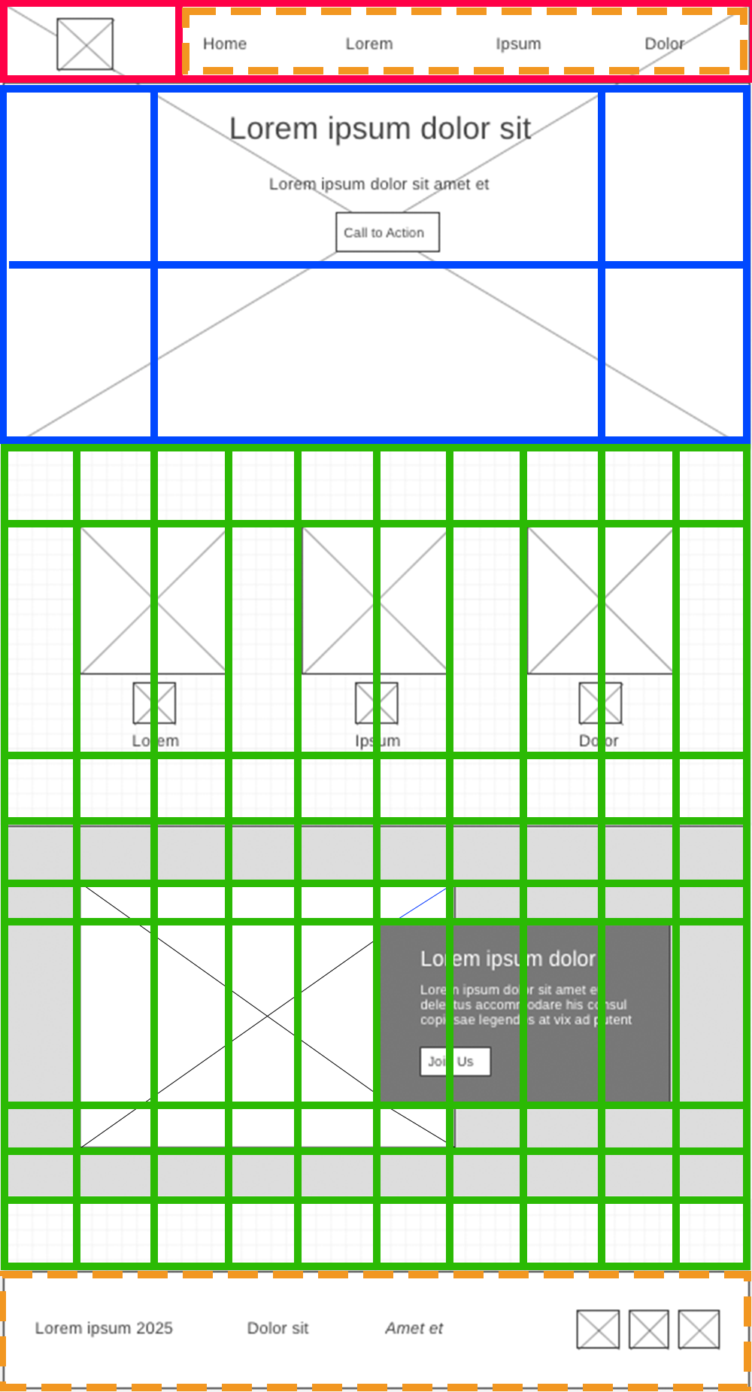

1

1

2

3

5

6

7

8

10

2

3

4

5

7

8

9

10

11

4

9

Column numbers

row numbers

footer  
uses flexbox

header  
uses grid

nav  
uses flexbox

#hero  
uses grid

.home-grid  
uses grid

3

2

1

2

1

3

6

4

3

2

1

1

2